Investment Proposal: Wedonet
Wedonet: Building Iraq's Gateway to the Global Digital Economy
An Investment Opportunity in the Premier AI-Powered Talent Partner
Prepared by: Ranja Ali, Founder & CEO
Website: www.wedonet.krd
Contact: contact@wedonet.krd

Comprehensive Introduction to Wedonet

Wedonet is a pioneering force in the Middle Eastern digital economy, established in 2017 with a powerful mission: to unlock Iraq and Kurdistan's immense human potential and connect it to the global market. We are not just a platform; we are a curated, high-trust talent marketplace and a managed service provider that bridges the critical gap between skilled local freelancers and international clients demanding excellence.

We operate on a unique "Prime Contractor" model. This means clients don't just hire freelancers; they hire Wedonet. We take full responsibility for vetting talent, managing projects, ensuring quality control, and guaranteeing on-time delivery, thereby eliminating risk for our clients and ensuring fair, secure payment for our professionals.

Our work is built on a foundation of proven results and elite trust. To date, Wedonet has:

Generated over $100,000 in platform revenue and facilitated over $500,000 in total project value into the local economy.

Built a robust network of 200+ rigorously vetted freelancers across 30+ areas of expertise, including web development, marketing, design, and technology.

Successfully delivered 150+ projects for a prestigious portfolio of clients that includes United Nations agencies (UNODC, UN-Habitat), Al Jazeera, Invest Kurdistan, and many other international organizations.

From our founding in 2017, we have grown into Iraq's premier gateway for digital talent. We are more than a service; we are a movement dedicated to empowering a generation, driving economic growth, and changing the global narrative about the talent and potential within Iraq and Kurdistan.

Our core promise is simple: To provide global clients with exceptional, cost-effective, and reliably managed talent, while offering Iraqi and Kurdish professionals the prestigious global opportunities they deserve.

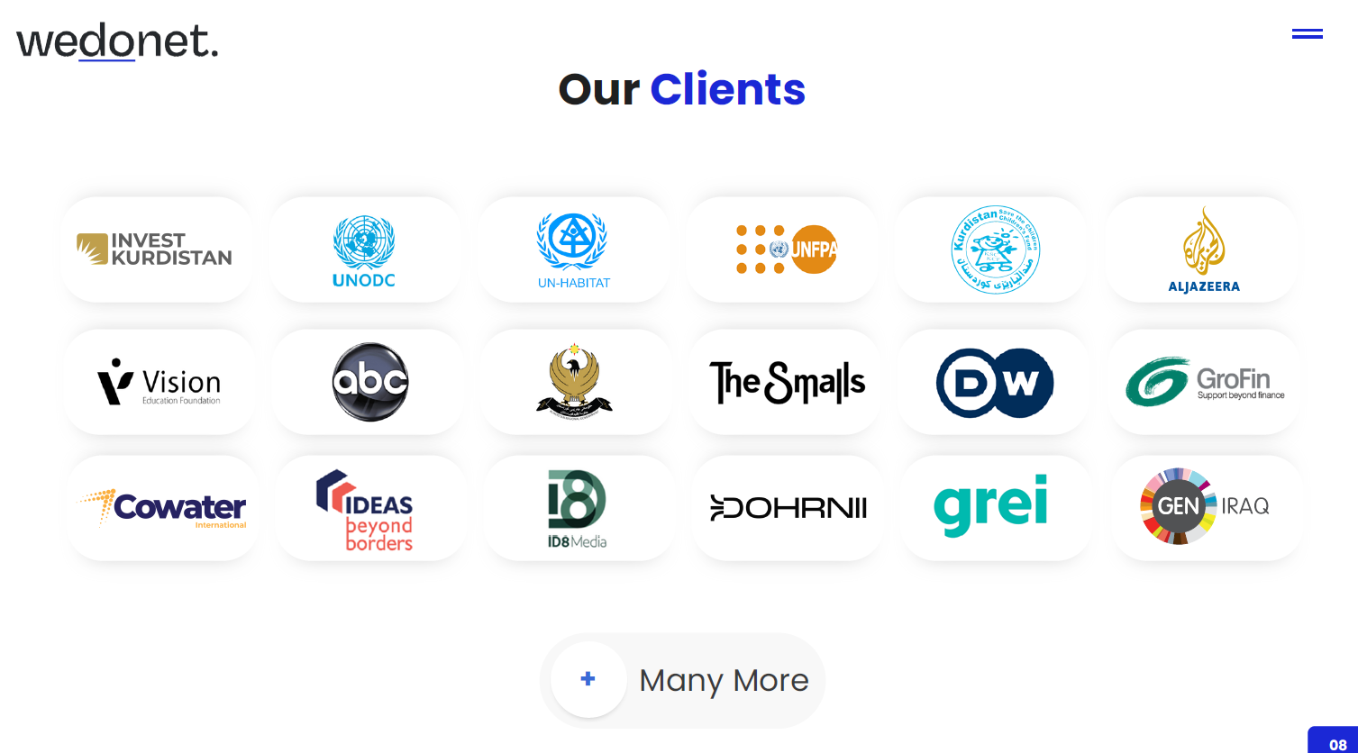

1. Executive Summary
Wedonet is a curated, high-trust talent marketplace connecting vetted Iraqi and Kurdish professionals with elite international clients. We solve a critical paradox: youth unemployment exceeding 20% in Iraq, with over 200,000 skilled professionals remaining untapped, versus a global economy seeking skilled, cost-effective digital talent.
Our proven model has delivered over $500,000 in project value to prestigious clients including the United Nations, Al Jazeera, and Invest Kurdistan, generating revenue and establishing unmatched credibility. We are seeking $350,000 for 15% equity to execute a three-pillar growth strategy. This investment is projected to drive revenue to $500,000 in Year 1, $1.2M in Year 2, $7M by Year 5, and $15M within 10 years, offering investors a clear path to a 15x-20x financial return and an unparalleled legacy as nation-builders in the Arab world.

2. The Problem: The Paradox of Untapped Potential
- National Crisis: Iraq and Kurdistan face significant waste of human capital. Over 200,000 young professionals in fields like IT, engineering, and design face limited opportunities, leading to brain drain and economic stagnation.
- Global Shortage: International markets face an acute shortage of digital talent:
  - UAE Vision 2031 and Saudi Vision 2030 have created demand for hundreds of thousands of technical professionals that cannot be met locally.
  - The US and Europe represent a $4.1+ billion freelance management market.
- The Missing Bridge: The barrier is not lack of skill, but a critical gap in trust, reliable payment systems, and professional project management between international clients and Iraqi talent.

3. The Solution: The Trusted Bridge
We are not just another platform, but an active, high-value "Prime Contractor."
- Curated Talent Network: We don't just list freelancers; we vet, train, and certify professionals across 30+ specialization areas to ensure world-class delivery.
- Managed Service with Delivery Guarantee: Clients work with Wedonet, not individuals. We assume full responsibility for project management, quality control, and timely delivery, eliminating client risk.
- Seamless & Secure Operations: Our system includes secure payments, ensuring freelancers receive fair and prompt compensation while guaranteeing client satisfaction.

4. Traction & Validation: Proof of Success
We've transitioned from concept to practical execution, earning the trust of the world's most demanding organizations.
Metric | Achievement | Significance
Platform Revenue | Over $100,000 | Proven revenue-generating business model
Total Project Value | Over $500,000 | Significant, measurable economic impact
Freelancer Network | 200+ qualified professionals | Scalable and growing asset
Completed Projects | 150+ successful projects | Demonstrated execution capability
Elite Client Portfolio | UN, Al Jazeera, Invest Kurdistan | Highest level of trust and validation

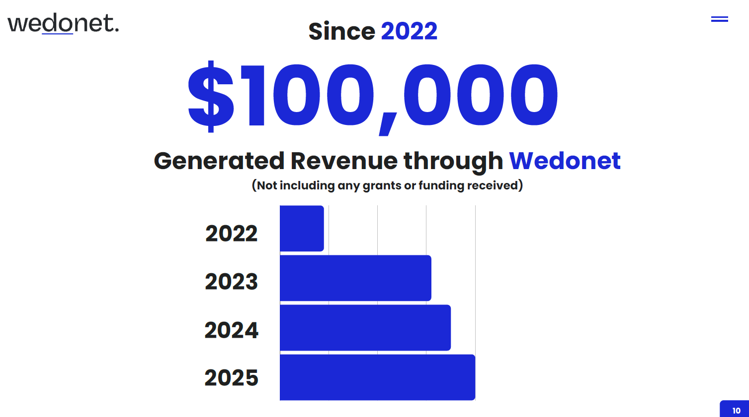

5. Market Opportunity & Competitive Analysis
Total Addressable Market: The global freelance platform market is valued at $6.5 billion with 15% annual growth. Our strategy focuses on capturing high-value segments.
Region | Market Opportunity | Competitive Advantage
Gulf Countries | Over $5 billion | Cultural & Linguistic Alignment - Local talents understanding Arab business environment
US & Europe | $4.1 billion | US-Based Management - Ensuring seamless communication and high quality
Iraq & Kurdistan | 200,000+ professionals | Market First-Mover - Client trust and strong local partnerships

6. Financial Projections & ROI
Our projections are based on capturing a conservative portion of the identified market demand.
Year | Projected Revenue | Key Milestones
Year 1 | $500,000 | Establish UAE presence, onboard first 20 clients
Year 2 | $1.2 million | Expand to 100+ clients, launch AI tools
Year 3 | $3 million | Regional dominance, expand to KSA and Qatar
Year 5 | $7 million | Exit Target: Acquisition or strategic investment
Year 10 | $15 million | Industry leadership across MENA region
Investor Return: We project 15-20x return within 5 years

7. The Ask: $350,000 Growth Allocation
This investment represents precise fuel for massive growth, distributed across three pillars:
Pillar | Allocation | Actions & Outcomes
Market Expansion | $150,000 | Establish UAE office, hire freelancers across regions
Technology & AI | $120,000 | Develop AI tools, regional expansion
Academy Development | $80,000 | Train 1,000+ freelancers, ensure quality excellence

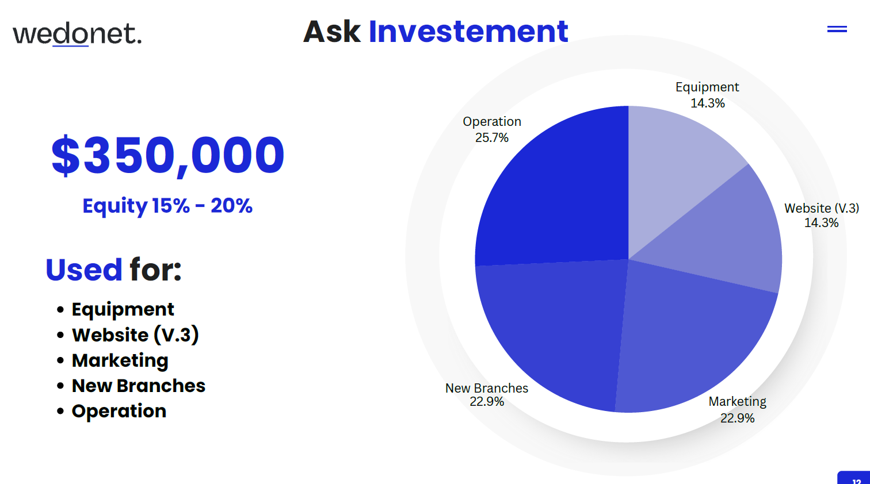

8. The Team: Experienced Local & Global Leaders
- Ranja Ali: 8+ years experience building Wedonet
- Havai Othman: Former Senior Director at HP & General Manager of US based Office
- Abbas Ali: 16+ years compliance experience
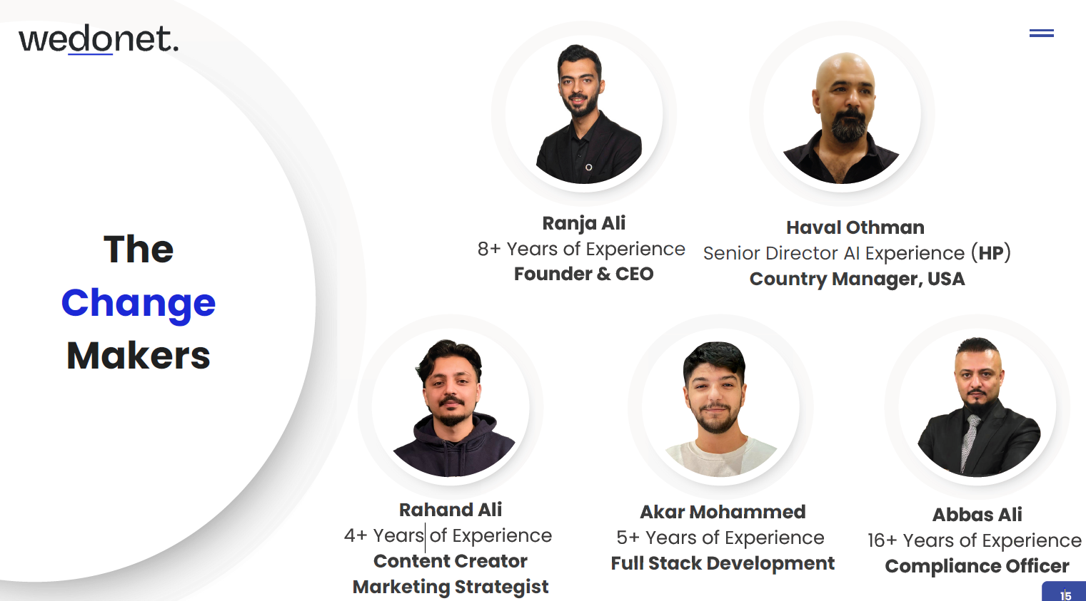

9. Investor Opportunity: Profit & Purpose
Your investment delivers dual returns:
- Financial Return: Clear path to 15-20x return
- Legacy: Nation-building, economic development, and social impact

10. Conclusion
The world seeks talent. Iraq possesses it. We've built the only trusted bridge between them. We have the model, clients, team, and strategy. We invite you to join us in building a prosperous future.

